NOTIFICATION OF INTENT TO SUBAWARD

Date: January 17, 2018

To: All Vendors

From: State of Nebraska, Buyer
                - Nebraska Energy Office

Subject: RFP Number: RFP2017DCo

This is to notify all vendors who responded to the above-referenced Request for Proposal that the State of Nebraska Energy Office intends to subaward the contract for service provider for the Weatherization Assistance Program for Douglas County to Habitat for Humanity of Omaha.

Thank you for your interest in doing business with the State of Nebraska.

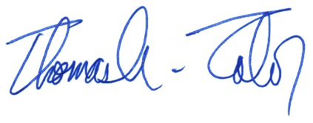
Thomas A. Tabor
Weatherization Assistance Program Division Chief
Nebraska Energy Office

